Application For Summer School

1. Personal Information
photo  (3✕4cm) |  | Name | Family  Name |  | Given  Name
 |  | Address
 |  | E-mail |  |  | Nationality
 |  | Phone Number |  |  | Dormitory Application | Yes / No
 |  | Gender | ☐Male ☐Female |  | Date of Birth  (YYYY/MM/DD)
※ Please insert your JPG file.
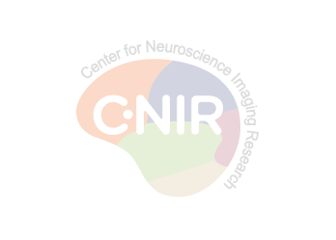
2. Education
Name of School | Major | Grade | GPA
High school | - | - | -
College |  |  | /

3. Lab Preference ※ Please write the professor’s name of your priority.
1st |  | 2nd |  | 3rd

4. S/W Skills ex) Matlab, CAD
Write down computational or imaging software you are familiar.

5. Recommendation ※ Please arrange to send a recommendation letter directly to the Summer School office. (EMAIL: jooheeoh@skku.edu)
Professor’s  Name |  | Email address |  | Phone number
7. Self-Introduction
※ Please introduce yourself such as experience relevant to brain science or engineering, college courses and extracurricular activities, etc.

8. Describe Reasons for applying the Summer School and Carrer Plan
※ Please describe why you are interested in the Summer Program (such as exploring graduate schools), what will be your short-term and long-term career plan, and anything useful for evaluation of your application.

